1. What is Boolean? Write down 3 different expression that results a Boolean type (i.e. 5 == 6)

* A Boolean value is either true or false. For exp: 'dog' != 'cat, 42 == 42.0, 'hello' == 'Hello'

1. What is a flow chart? Draw flow chart for the following code snippet: (you can draw on a paper, take a picture of it)

if name == “Huy be":

print(“Hand some")

elif name == “Huy big":

even_more_handsome = True

else:

webbrowser.open(“<https://www.youtube.com/watch?v=04854XqcfCY>”)

* 1. A flowchart is a type of diagram that represents a workflow or process
  2. Draw:

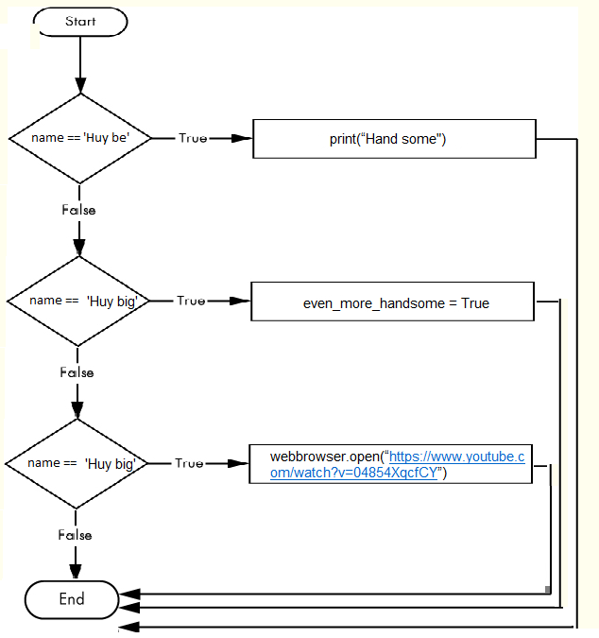

1. What is nested conditionals? Write a piece of code that uses nested conditionals

* The situation in which one conditional is nested within another. For exp:

var = 100

if var < 200:

print("Expression value is less than 200")

if var == 150:

print("Which is 150")

elif var == 100:

print("Which is 100")

elif var == 50:

print("Which is 50")

elif var < 50:

print("Expression value is less than 50")

else:

print("Could not find true expression")

print("Good bye!")